# Dynamics UI Plugin Installation steps

1. Download the Unified Interface solution by following the instructions here: <https://www.autoaddress.ie/support/developer-centre/integrations/crm-integration-files>
2. From dynamics home page select the app you want to add Autoaddress to. Click the settings icon in the top right of the screen. Then select advanced settings

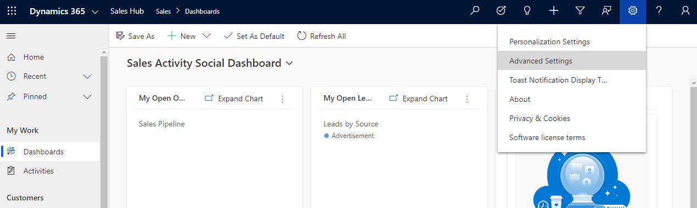

1. Click the drop down arrow next to settings in the top menu bar and select “Customisations”

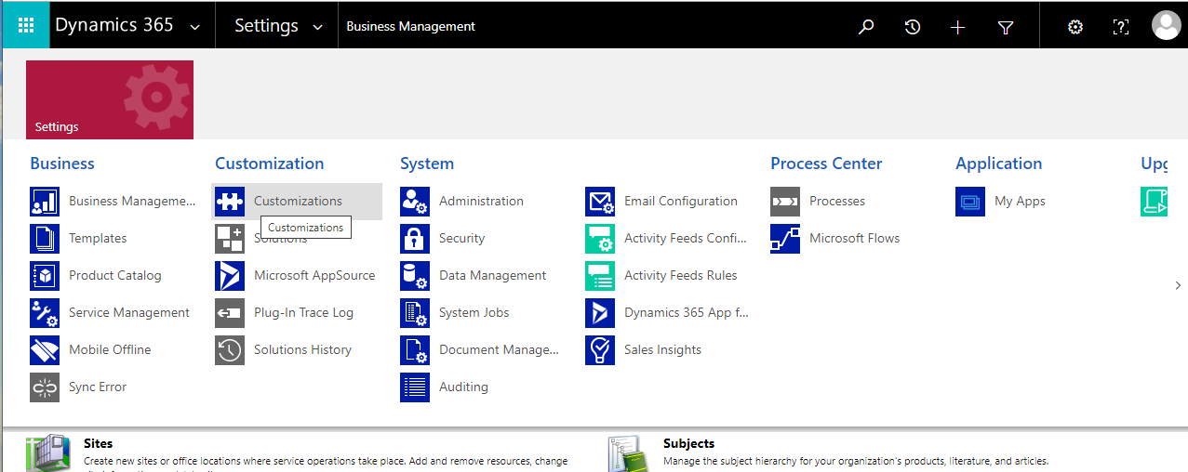

1. In the Customisation menu select “Customise the System”. This opens Power Apps.
2. If the classic version opens select “Try new experience”.
3. From here select “Solutions“ at the bottom of the left menu then click “Solutions“ at the top of the table to ensure you are in the top level of the menu
4. Select “Import“ at the top of the page

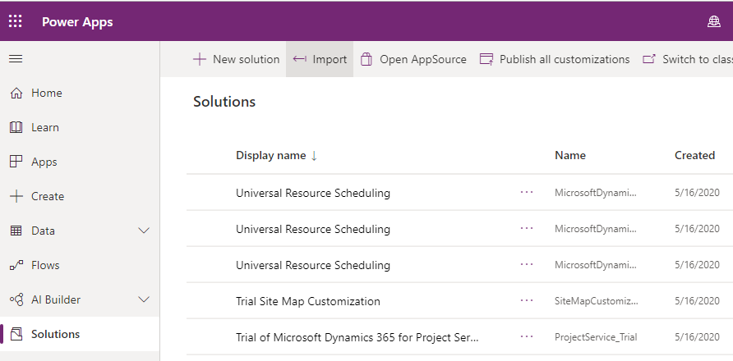

1. In the new window that opens, click “Choose file” and select the AutoaddressSolution.zip file downloaded in Step 1
2. Click “Next”, then click “Import”
3. When the solution is finished importing click “Publish All Customisations”

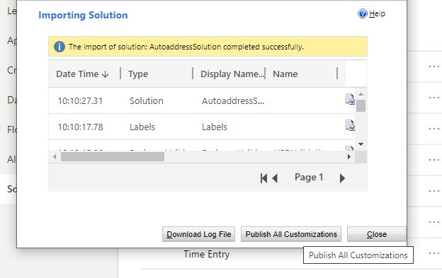

This may take a while. Select “Wait” if “Stopped responding” message appears

1. Click “Close“ – now the solution is imported. Next the control must be associated with a field.
2. Select the Data dropdown in the left menu of PowerApps
3. Select “Entities“ then select the Entity with the form you want to attach the plugin to (Contact in this example)

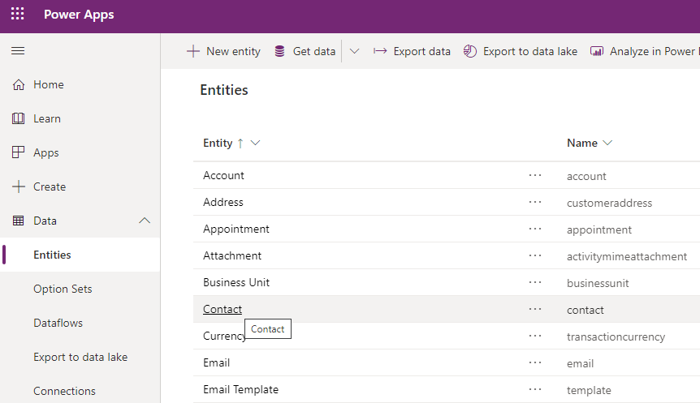

1. While “Fields“ is the selected tab, click “Add Field“ in the top left. Field properties input should appear.

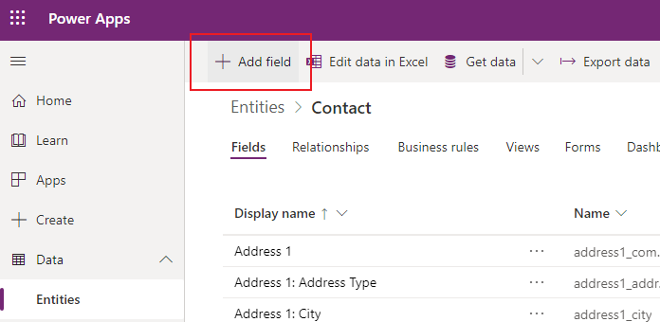

1. This is the field we will attach the control to so give it a relevant name such as Address Search. Click “Done“.

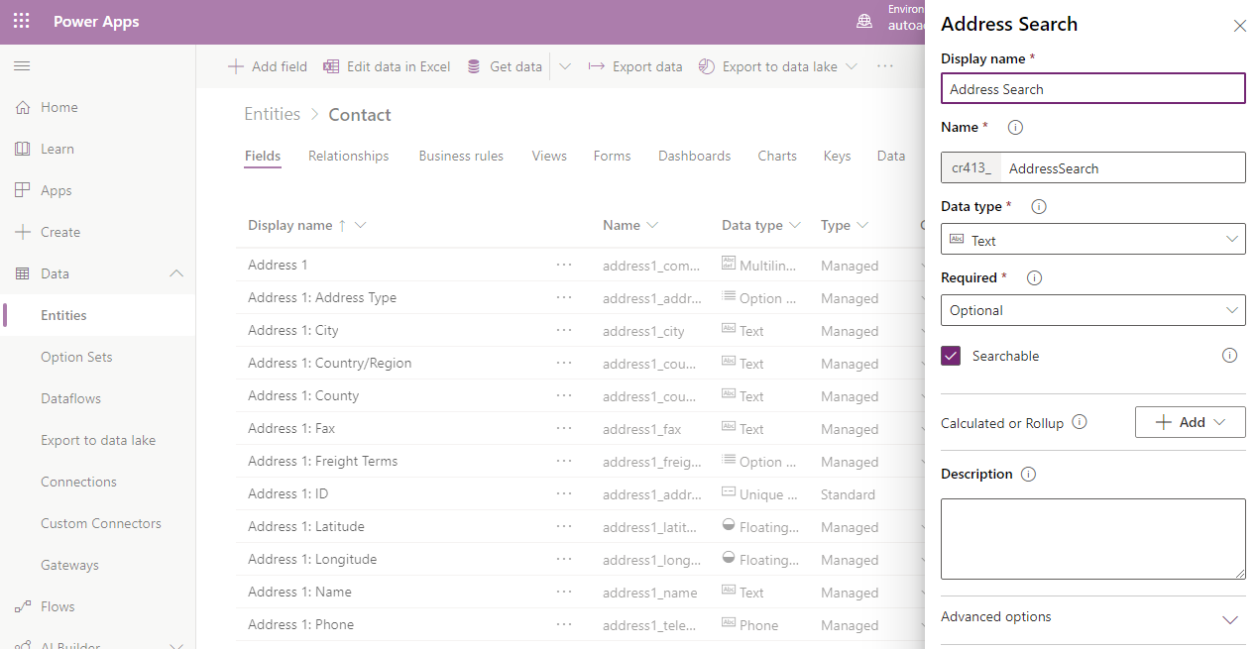

1. Click “Save Entity“ at the bottom right of the screen
2. Now select the “Forms“ tab, then select the form you want to attach the plugin to (e.g. Contact)

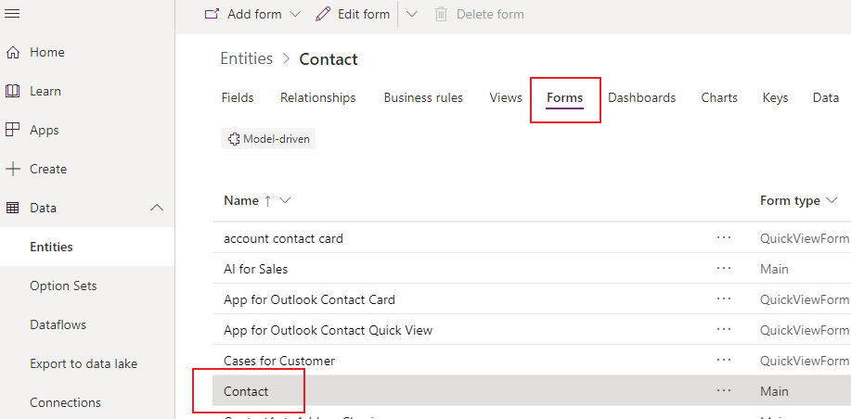

1. Select “Switch to Classic” from the top menu bar of the Form page.

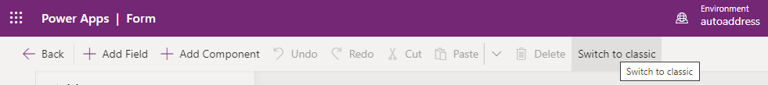

1. Find the newly created field in the fields menu and drag it into the form above the address details.

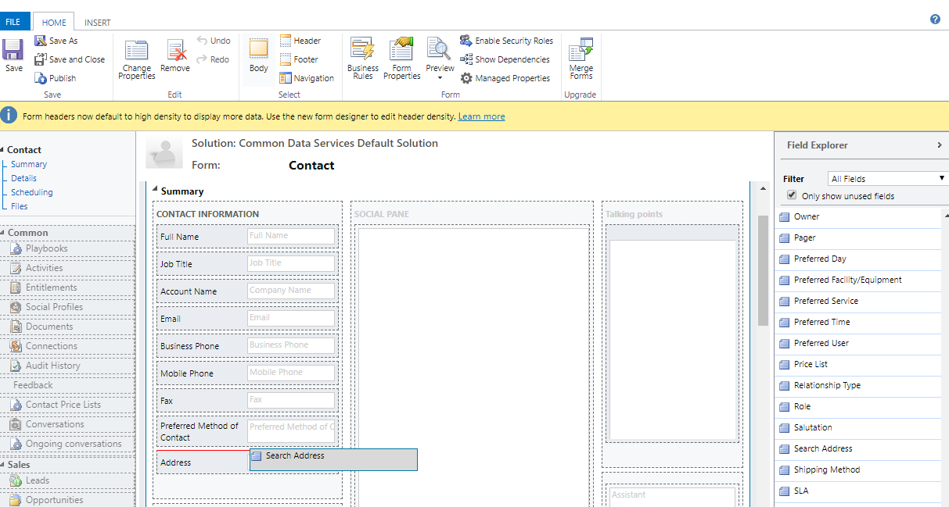

1. Double click the field you want to attach the control to
2. Select “Controls“ tab in field property
3. Click “Add control“. Select the “Autoaddress Search Component“ from list

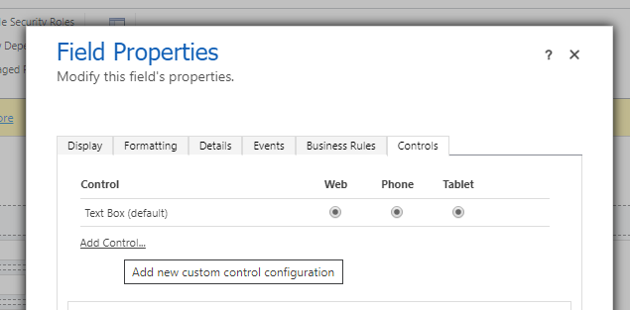

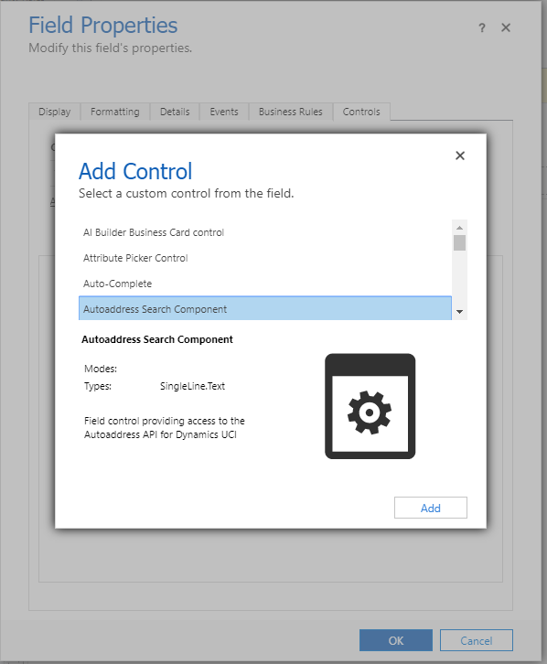

1. Select formats plugin should appear on (web/tablet/phone)

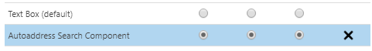

1. Select edit icon on API key. Add API key to field. Click ok.

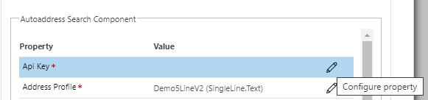

1. For each of lines 1-5 click the edit icon and select from the dropdown the field you want that line to appear in. Do the same for the Postcode.

**Note**: if using the composite address fields, “address1_line1” etc., some fields may not be available, specifically lines 2 and 3. Please continue to add as many fields as possible and continue with these instructions. Once finished, see the “Include missing composite address lines” section below for details on how to add these fields.

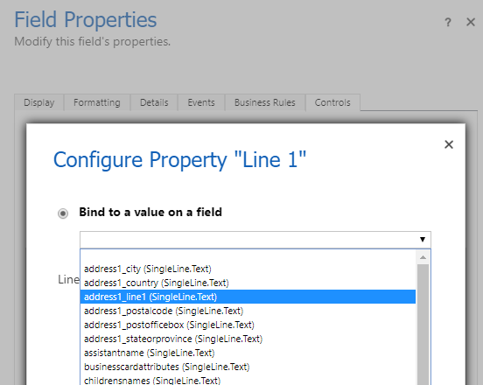

1. Click “Ok“
2. Save and publish the form.
3. Return to the main Dynamics App. Select the Form you added the Autoaddress control to (Contact). Click “New“. 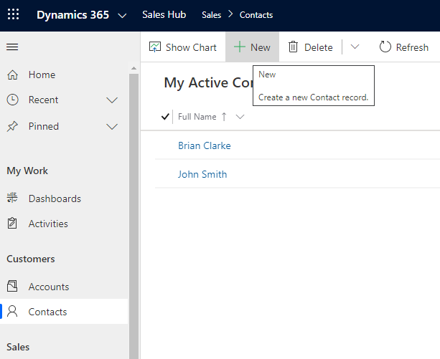
4. You should see the new field there with “Enter address” message there. Start typing address or enter Eircode to see results.
5. If the new field does not appear make sure the edited contact form is selected from the drop down

# Including missing Composite address lines

At the time of launch, some features of the Unified Interface have not been fully implemented. Specifically, if you are using the Composite Address Field (i.e. Address 1: Street 1 etc.) some lines may not be available when selecting them in the Autoaddress control field properties menu, namely Street 2 & Street 3.

In order to connect the Autoaddress output to the missing fields it is necessary to use the Power Apps’ Business Rules feature. First we will create substitute fields to populate from the Autoaddress output. We will then create a rule that will populate the composite address fields from data in the substitute fields.

1. Go to PowerApps (You can go to make.powerapps.com - Ensure you are in the correct Environment).
2. Select “Data“ in the left menu. Then select “Entities“. Select the Entity for the form you are adding the control to, e.g. “Contact”.

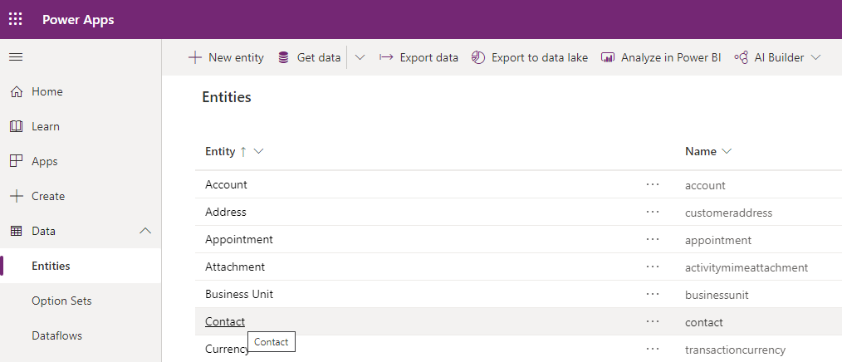

1. Select “Add Field“ and create a field for each of the missing lines. Name them something like “a_line2”. Click “Save Entity“.

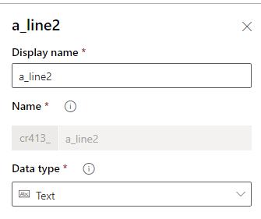

1. Select the “Business Rules“ tab and click “Add New Business Rule“. This should open the business rule screen.

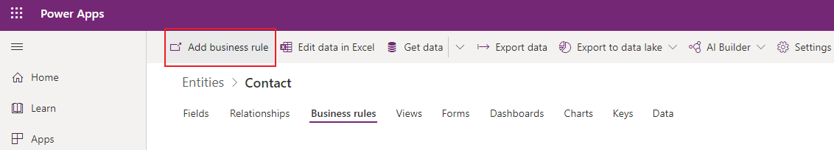

1. Click the dropdown arrow next to Contact: New business rule. Change the name to Autoaddress business rule. Add a description if desired.

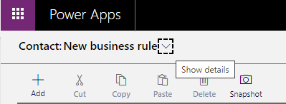

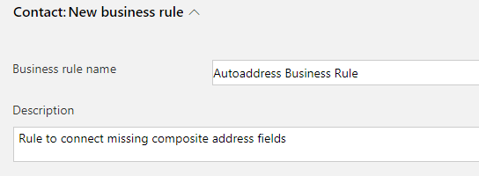

1. Click on the condition component in the canvas drawing area. In the properties panel that opens up, Set the name to “Autoaddress Condition“.

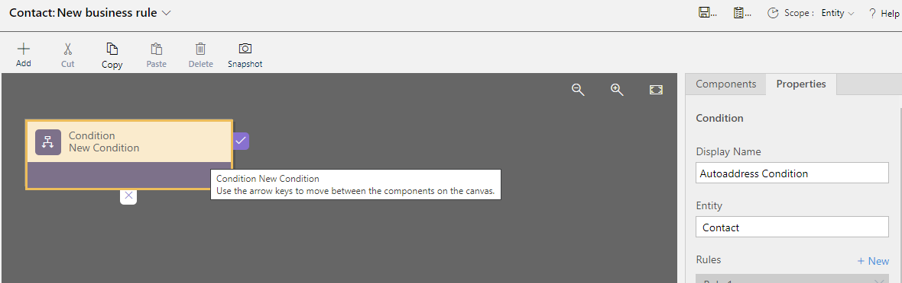

1. In Rule 1 under the Field dropdown, select one of the fields you added to the entity earlier (a_line2 etc.). Under Operator, select “Contains Data”.

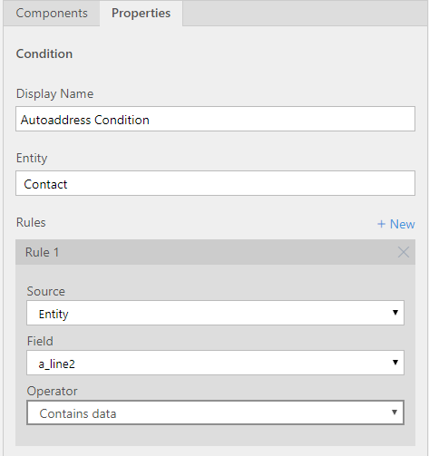

1. Above the Rule box select “New” to create a new rule. Copy the previous rule but under Operator, select “Does not Contain Data”.

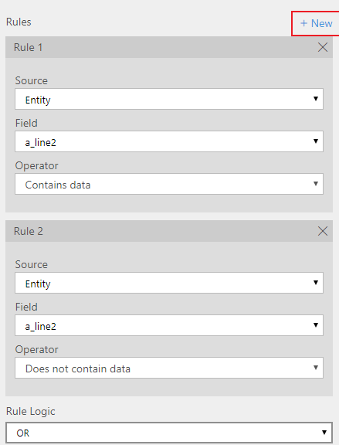

1. Repeat the previous step, creating these two rules for each of the fields you added.
2. When you have added a rule for each of the new fields, beneath the rules there is a Rule Logic dropdown. Select “OR“ from this dropdown and click “Apply“.
3. Select the Components tab next to the properties tab. Under Actions drag a “Set Field Value” action onto the canvas and attach it to the check mark on the Autoaddress Condition.

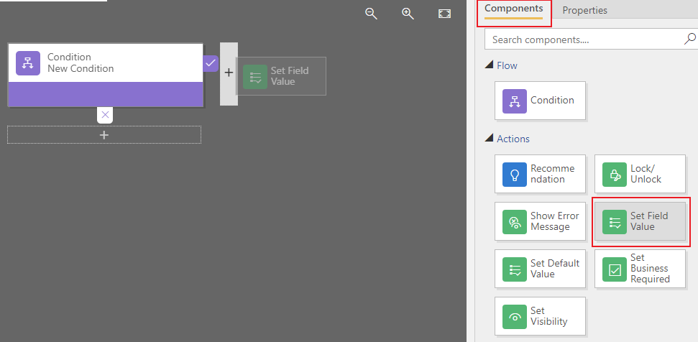

1. In the Properties tab that opens set the name of the Action to “Set Line 2”.
2. Under Field Value set the Composite Address field you want to set (i.e. Address 1: Street 2). Make sure it is the correct Composite Address group as there are 3 Composite Address groups.
3. Under “Type“ select “Field“.
4. Under “Field“, select the new field you added that corresponds to the field you are setting the data for (i.e. a_line2). Click “Apply“.

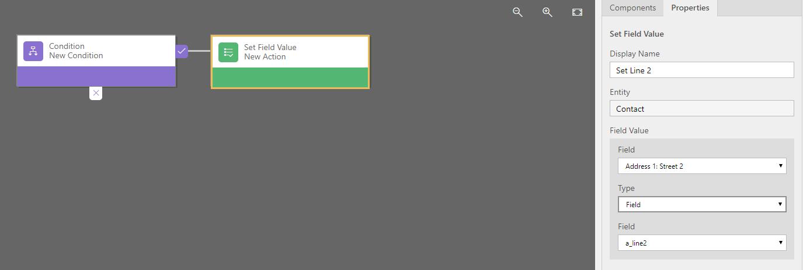

1. Repeat this process for each of the missing lines but instead of attaching the Action onto the Autoaddress Condition attach it to the previous Action. Be sure to name it correspondingly (i.e. “Set Line 3” for Address 1: Street 3 etc )
2. Once you have added Actions for each missing line, select “Validate“ in the top right of the screen. If the Validation fails. Review each of the steps to make sure nothing was missed.

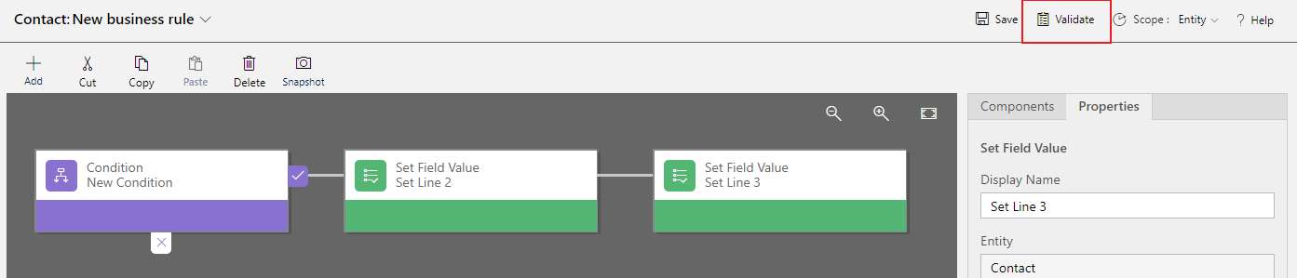

1. If the validation is successful click “Save“. When Saving is complete click “Activate“ and select “Activate“ in the pop-up that appears.
2. Once the rule is finished activating return to the Entity Page in PowerApps and click “Done“ on the “Creating a new Rule” message. The page should reload and you should be able to see the newly created rule.
3. Select the “Forms“ tab and select the form you have added the Autoaddress control to. Once in the form select “Switch to classic“ and double-click on the field you added the Autoaddress control to. Select the “Controls“ tab and select “Autoaddress Search Component“.
4. Click the “Edit” Icon next to one of the lines you created business rule actions for. From the dropdown select the field you added to the form (e.g. a_line2 – it may be prefixed with new_ or a unique identifier for your app). 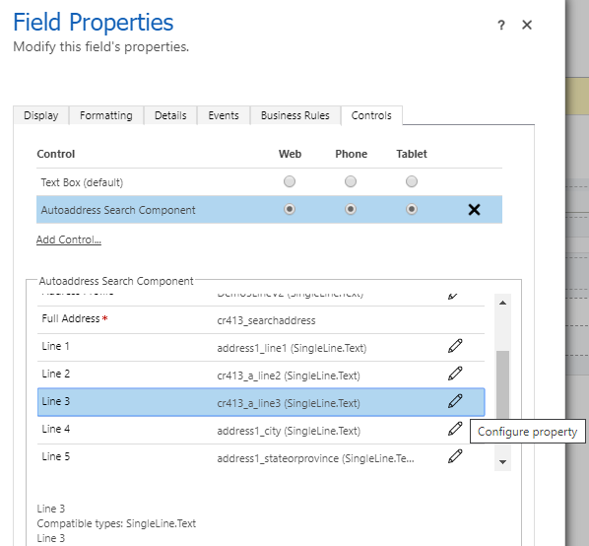
5. Click “Ok“. Repeat for each of the missing lines. Click “Ok“ to close the field properties menu.
6. In the Form Editor, find the custom fields in the Field Explorer panel and drag them into the form. Double click on one of the fields and in the properties panel that appears, deselect the “Visible by default” checkbox. Click “Ok “to close the field properties menu. Repeat this for each of the custom fields.
7. In the Form page click “Save“ and then “Publish“. Reload the form page in Dynamics and confirm that the fields are now populating correctly.

